Mini Twitter Project Documentation
Student name: Yevhen Pimenov
Student ID: 2419081
Module: Web Programming Practical Project_25_SE2
Lecturer: Dimitar Kazakov
Project: Mini Twitter

1. Project Overview
Mini Twitter is a full-stack social media application built with Next.js, TypeScript, Prisma, and SQLite. The application allows users to register, log in, create tweets, view tweets, edit and delete their own tweets, like tweets, follow other users, and view profile pages.
The main resource of the application is a tweet. Each tweet has a title, content, topic, mood, creation date, update date, author, and likes.

2. Technologies Used
- Next.js App Router for routing and server actions.
- TypeScript for typed application code.
- React for the user interface.
- Prisma ORM for database models, migrations, and queries.
- SQLite for the local development database.
- Tailwind CSS for page styling.

3. Main Features
- User registration with username, email, and password.
- Login and logout using a simple cookie-based session.
- Passwords are hashed before they are stored in the database.
- Guests can view public tweets and tweet details.
- Logged-in users can create new tweets.
- Users can edit and delete only their own tweets.
- Users can like and unlike tweets.
- Users can follow and unfollow other users.
- Tweets include title, content, topic, mood, created date, and updated date.
- The tweets page supports topic filters.
- Validation messages are shown for missing or invalid form input.

4. Database Structure
The database is managed with Prisma. The main models are:
- User: stores username, email, hashed password, creation date, posts, likes, followers, and following relationships.
- Post: stores tweet title, content, topic, mood, createdAt, updatedAt, and the user who created it.
- Like: stores which user liked which post and prevents duplicate likes.
- Follow: stores follower and following user relationships and prevents duplicate follows.

5. Application Pages
- Home page (/): landing page with navigation based on authentication state.
- Register page (/register): creates a new user account.
- Login page (/login): logs an existing user into the application.
- Tweets page (/tweets): shows tweet list, filters, likes, follow buttons, edit/delete for owners.
- New tweet page (/tweets/new): form for creating a tweet.
- Tweet details page (/tweets/[id]): shows one tweet with details and actions.
- Edit tweet page (/tweets/[id]/edit): form for editing an owned tweet.
- My profile page (/profile): shows current user information, stats, and personal tweets.
- User profile page (/users/[id]): shows another user profile and follow/unfollow action.

6. How to Run the Project
- Open the project folder in a terminal.
- Install dependencies with: npm install
- Create a .env file in the project root.
- Add this database connection string to .env: DATABASE_URL="file:./dev.db"
- Apply Prisma migrations with: npx prisma migrate deploy
- Generate the Prisma client with: npx prisma generate
- Start the development server with: npm run dev
- Open http://localhost:3000 in the browser.
- Optional checks: npm run lint and npm run build

7. Authentication Flow
When a user registers, the application validates the input, checks that the email or username is not already used, hashes the password, stores the user in the database, and sets a userId cookie. When a user logs in, the application checks the email and password, verifies the hashed password, and sets the same cookie. Protected pages and actions read this cookie to identify the current user.

8. CRUD Flow
Tweets are created, read, updated, and deleted through Prisma. Users can view all tweets and open a details page for one tweet. Logged-in users can create tweets. Edit and delete actions are protected so that a user can only modify records they created.

9. Validation and Error Handling
- Registration checks empty fields, invalid email, short password, and duplicate accounts.
- Login checks missing fields and wrong credentials.
- Tweet forms check empty title, long title, empty content, long content, invalid topic, and invalid mood.
- Unauthorized users are redirected to the login page or back to the safe page.
- Missing records use the not found page.

10. Development Log
- Set up the Next.js project and Prisma configuration.
- Added User model, registration, login, logout, and session helper.
- Added Post model and tweet creation/listing.
- Added full tweet CRUD with protected edit and delete actions.
- Added tweet details page.
- Added like/unlike system.
- Added username field and password hashing.
- Improved validation messages and safe delete confirmation.
- Added dedicated tweet create and edit pages.
- Added tweet title, topic, mood, and topic filters.
- Added profile pages and follow/unfollow user functionality.
- Updated README and prepared project documentation.

11. Problems Solved
- Protected actions were added so users cannot edit or delete tweets from other accounts.
- Plain-text password storage was replaced with password hashing.
- Prisma migrations were used to keep database changes structured.
- Form validation was added to handle common user mistakes.
- The interface was adjusted with clearer navigation and separate create/edit pages.
- Windows file-locking issues with SQLite were handled by stopping the local development server before database cleanup or restore.

12. Screenshots

Home Page
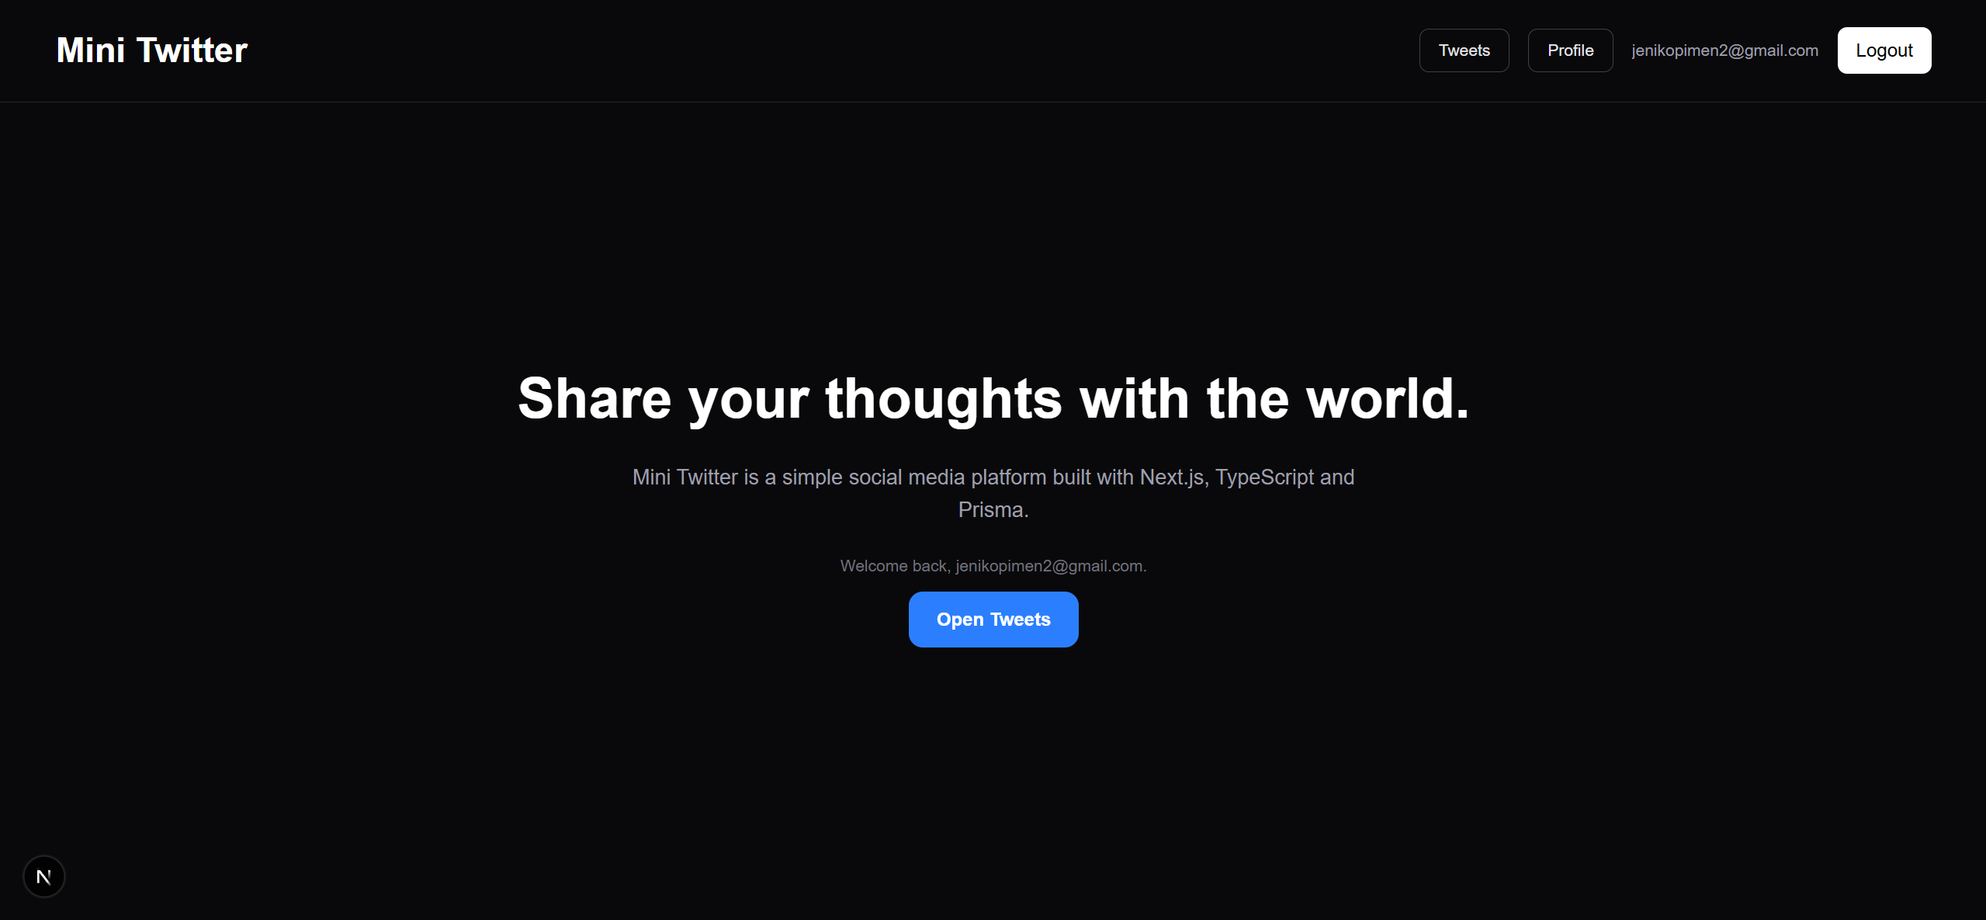

Register Page
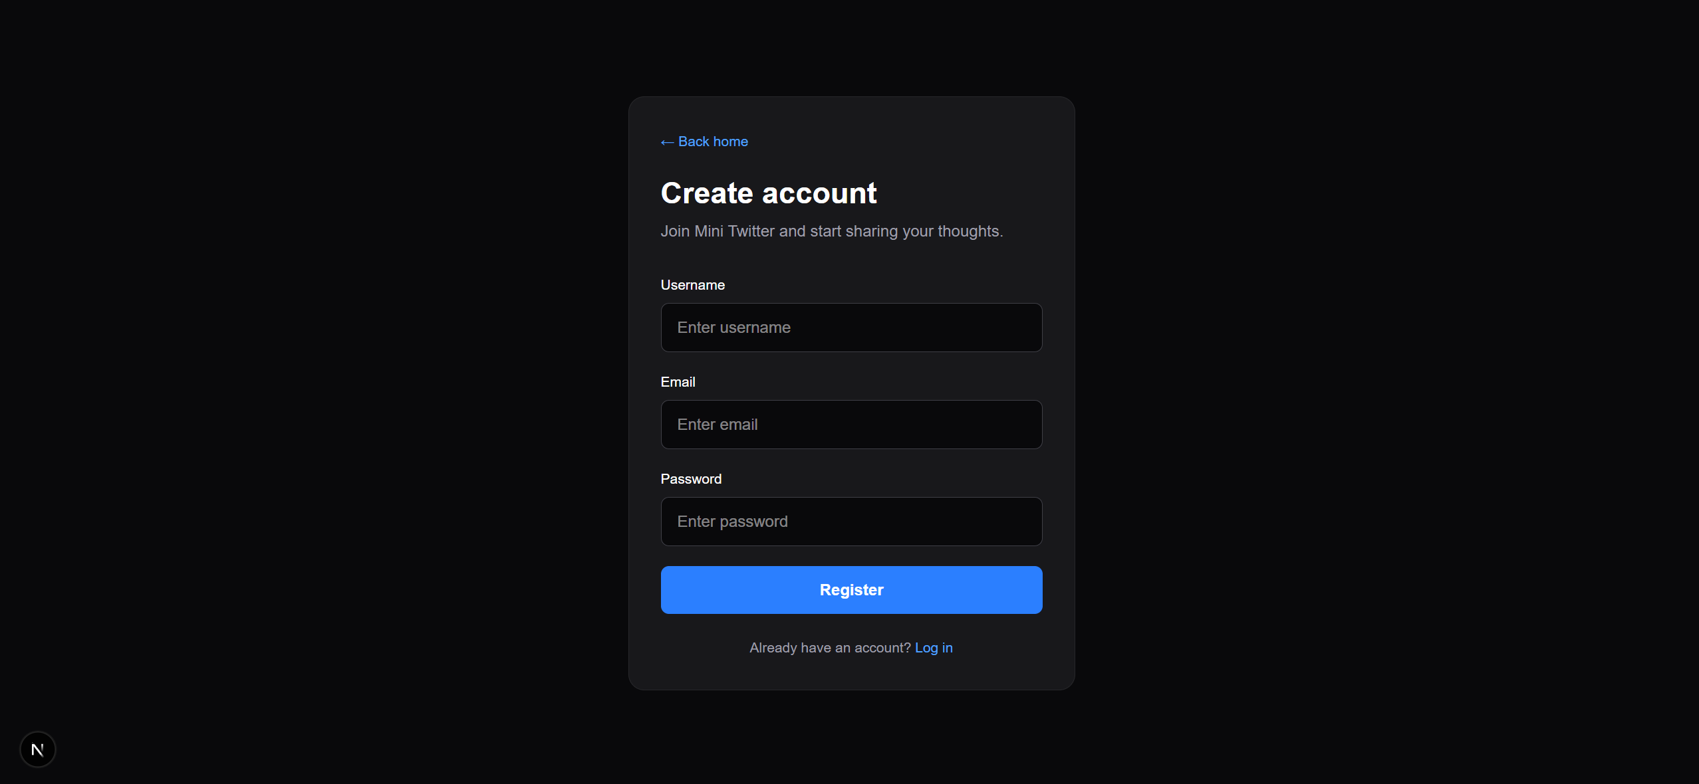

Login Page
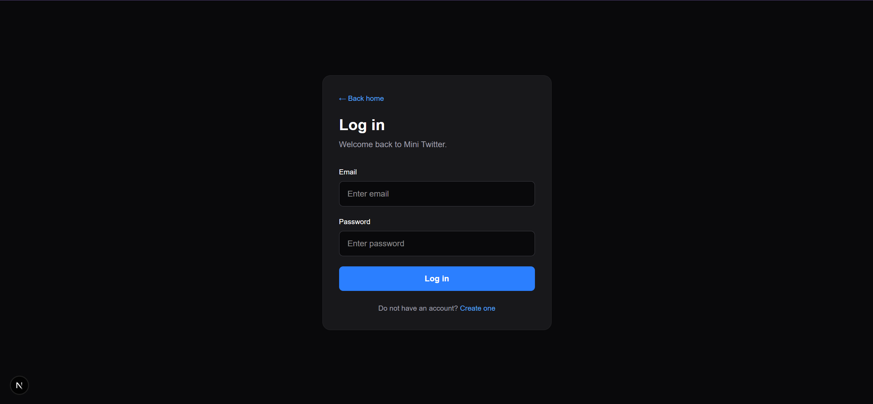

Tweets List Page
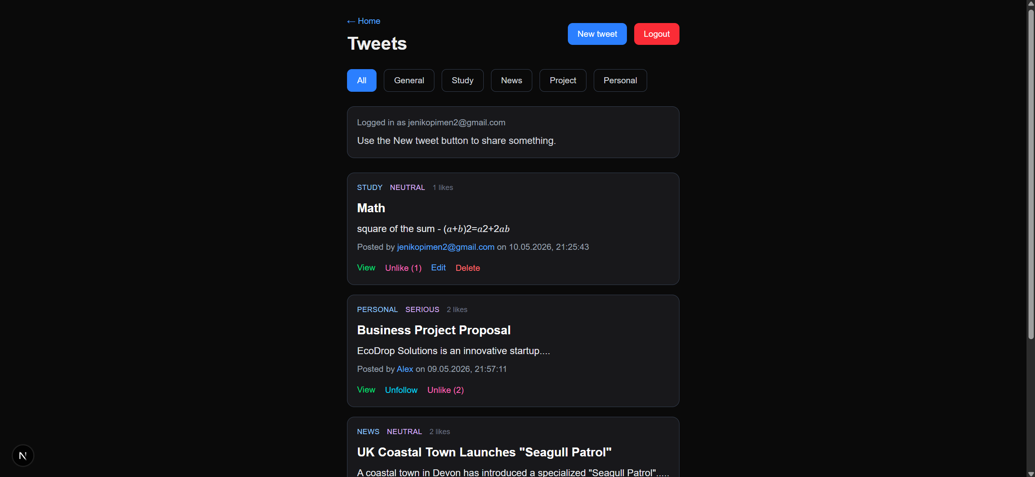

Create Tweet Page
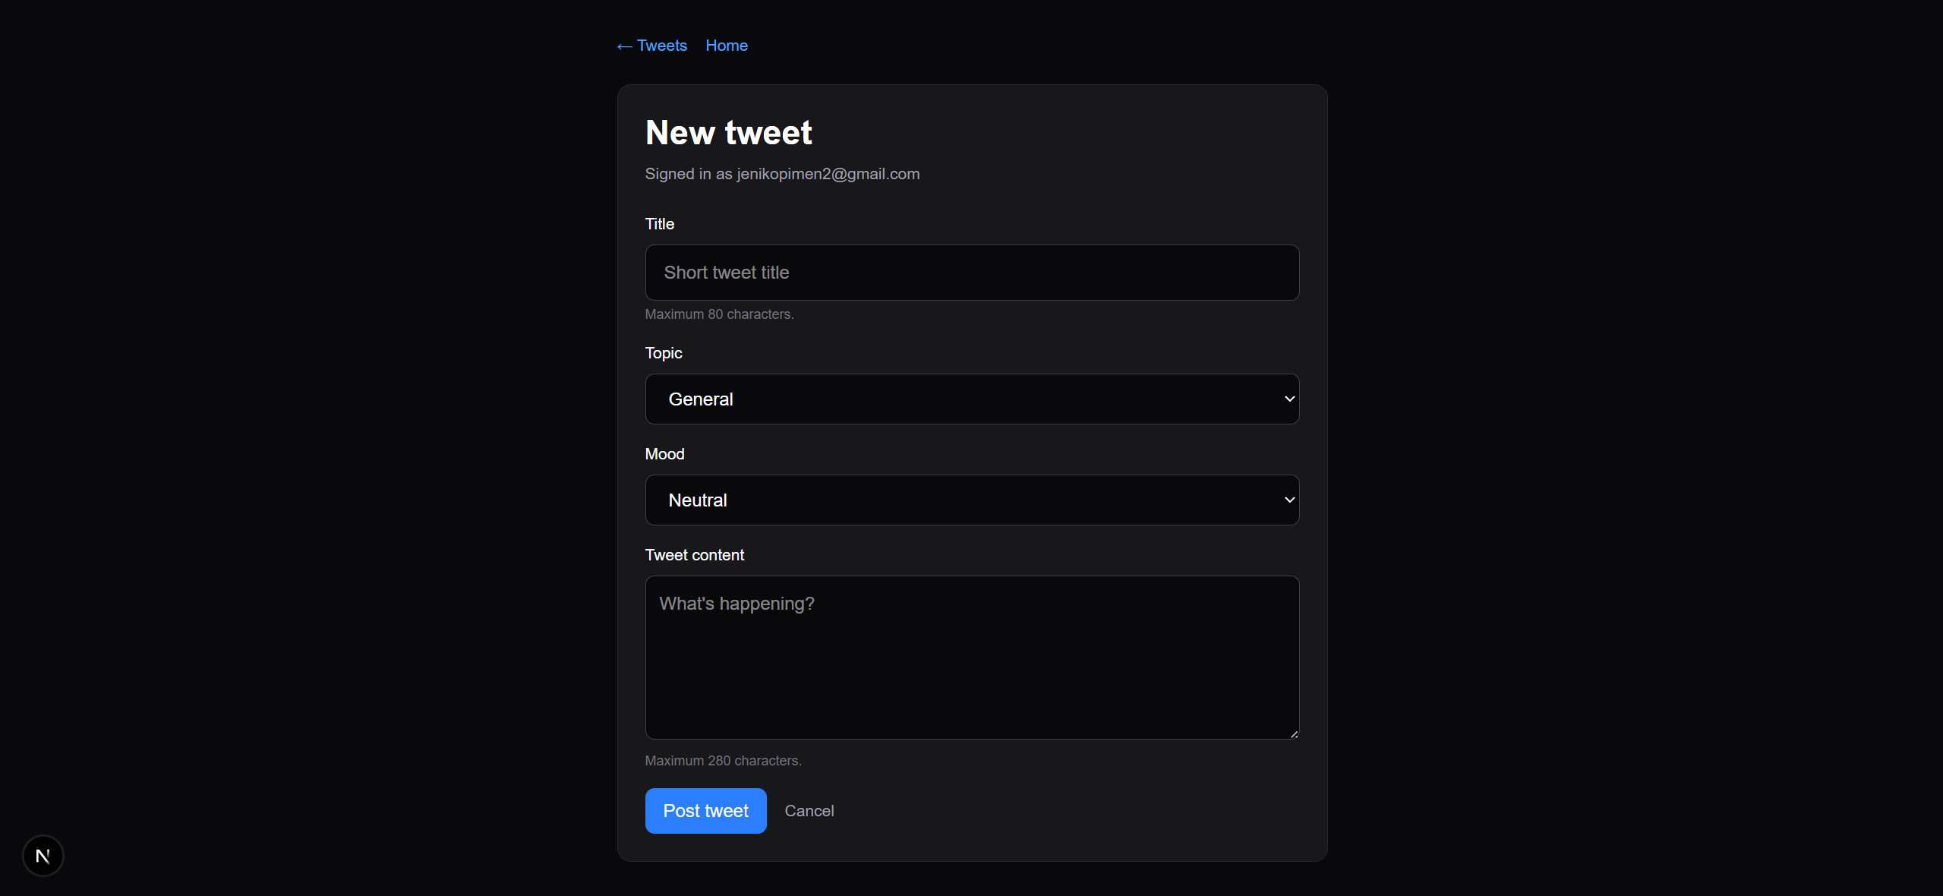

Tweet Details Page
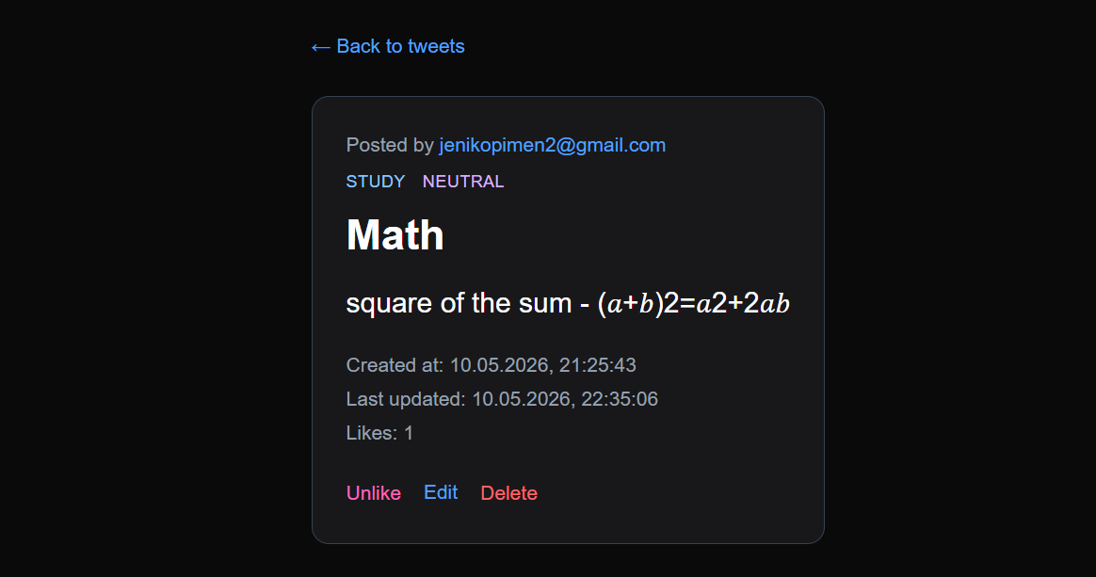

Edit Tweet Page
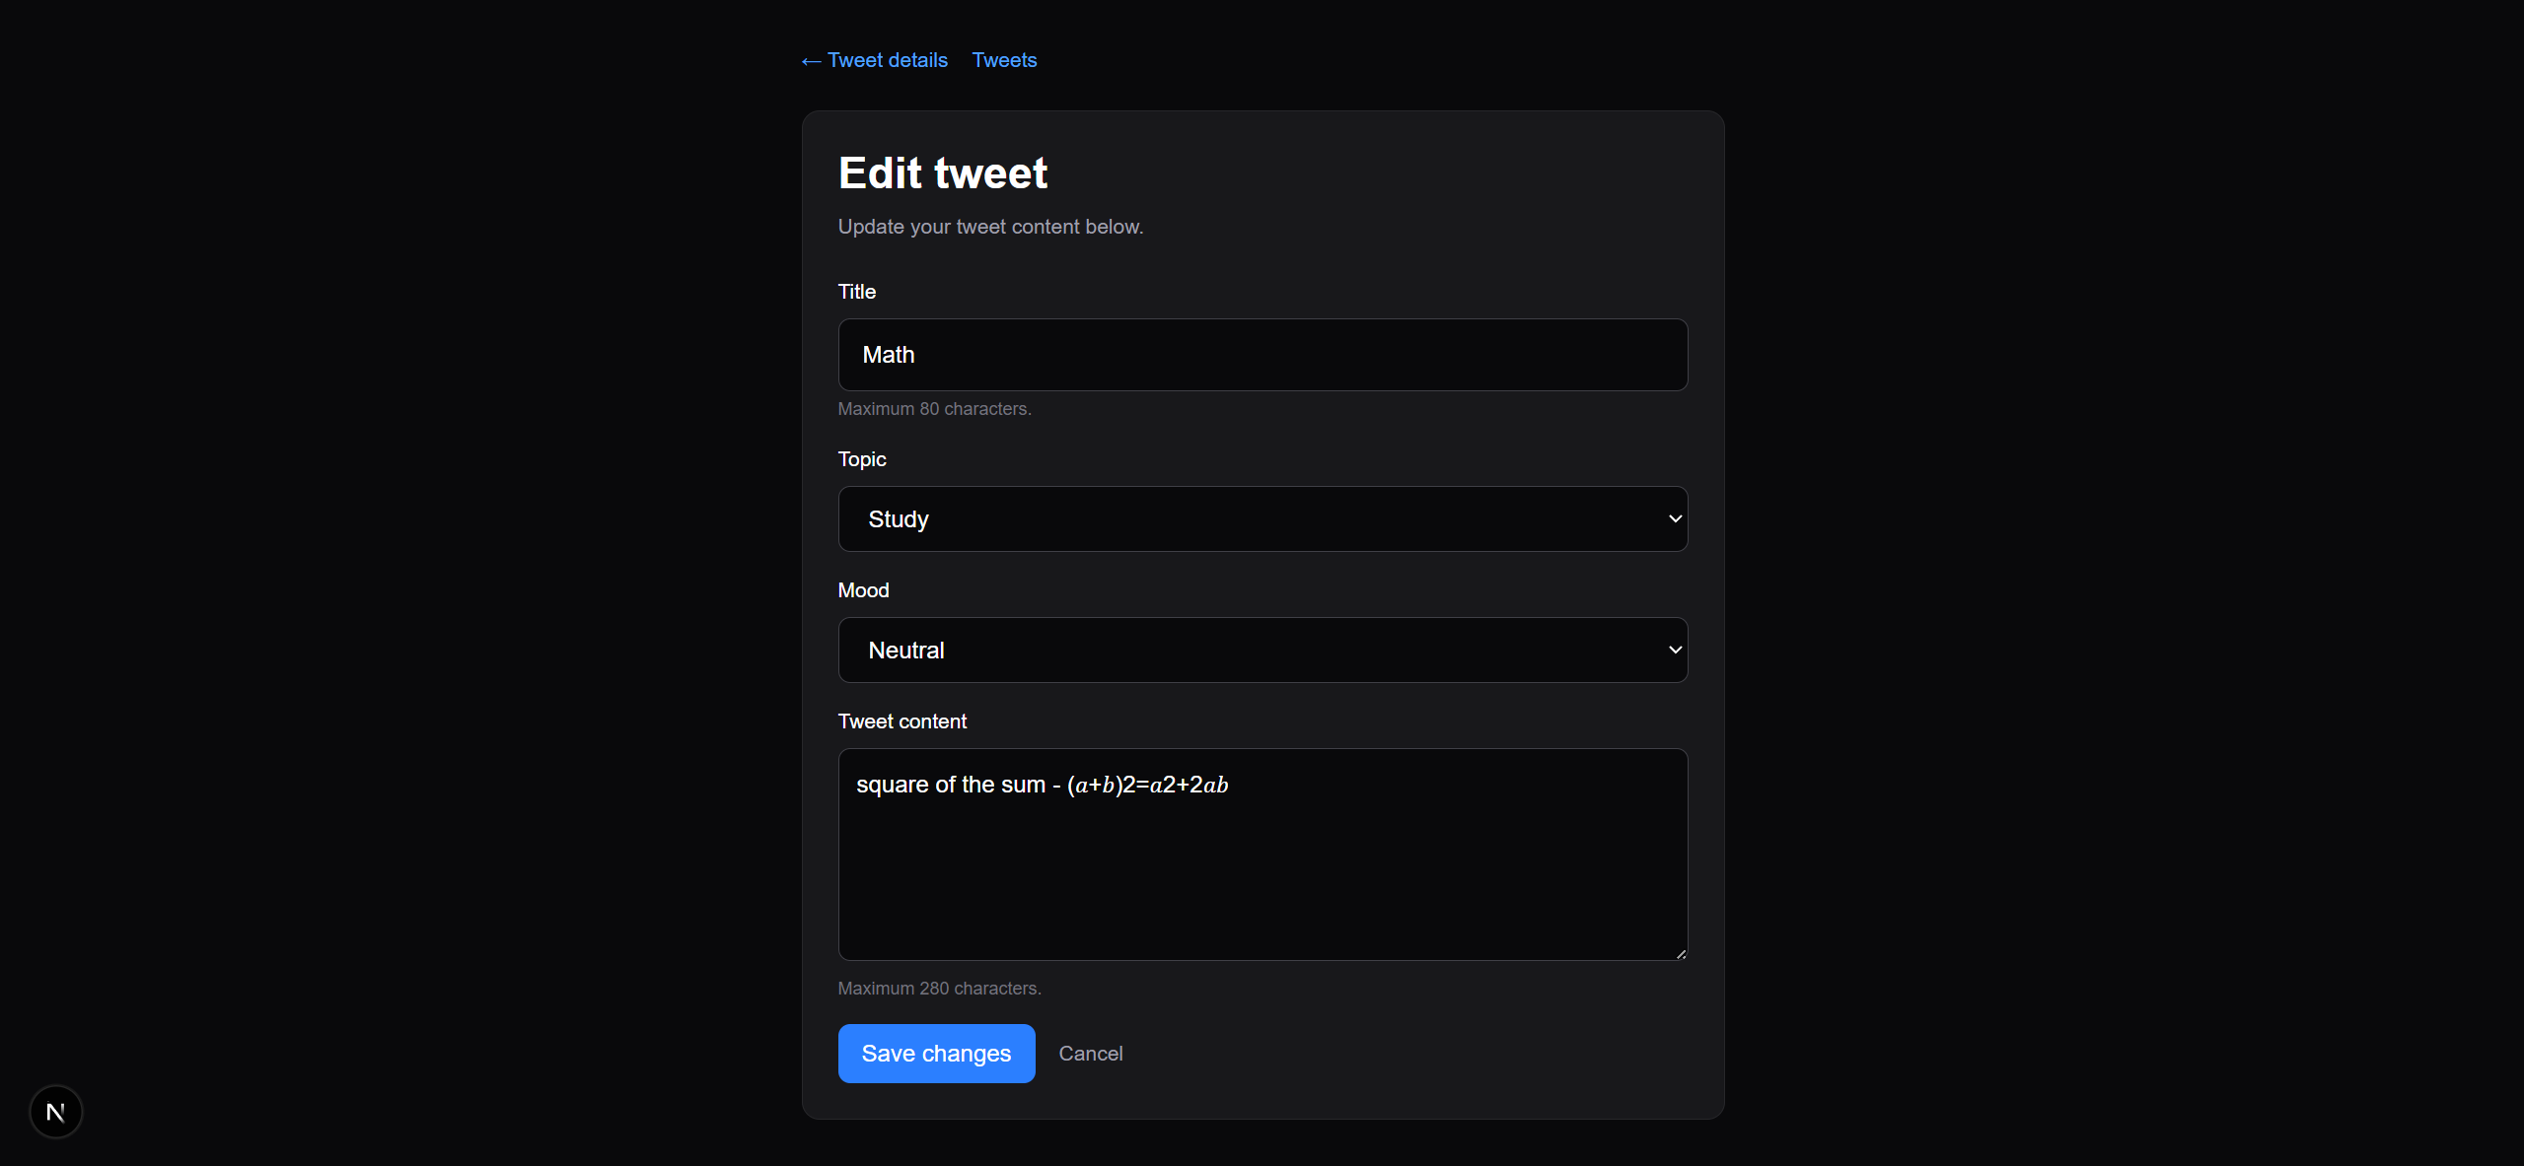

My Profile Page
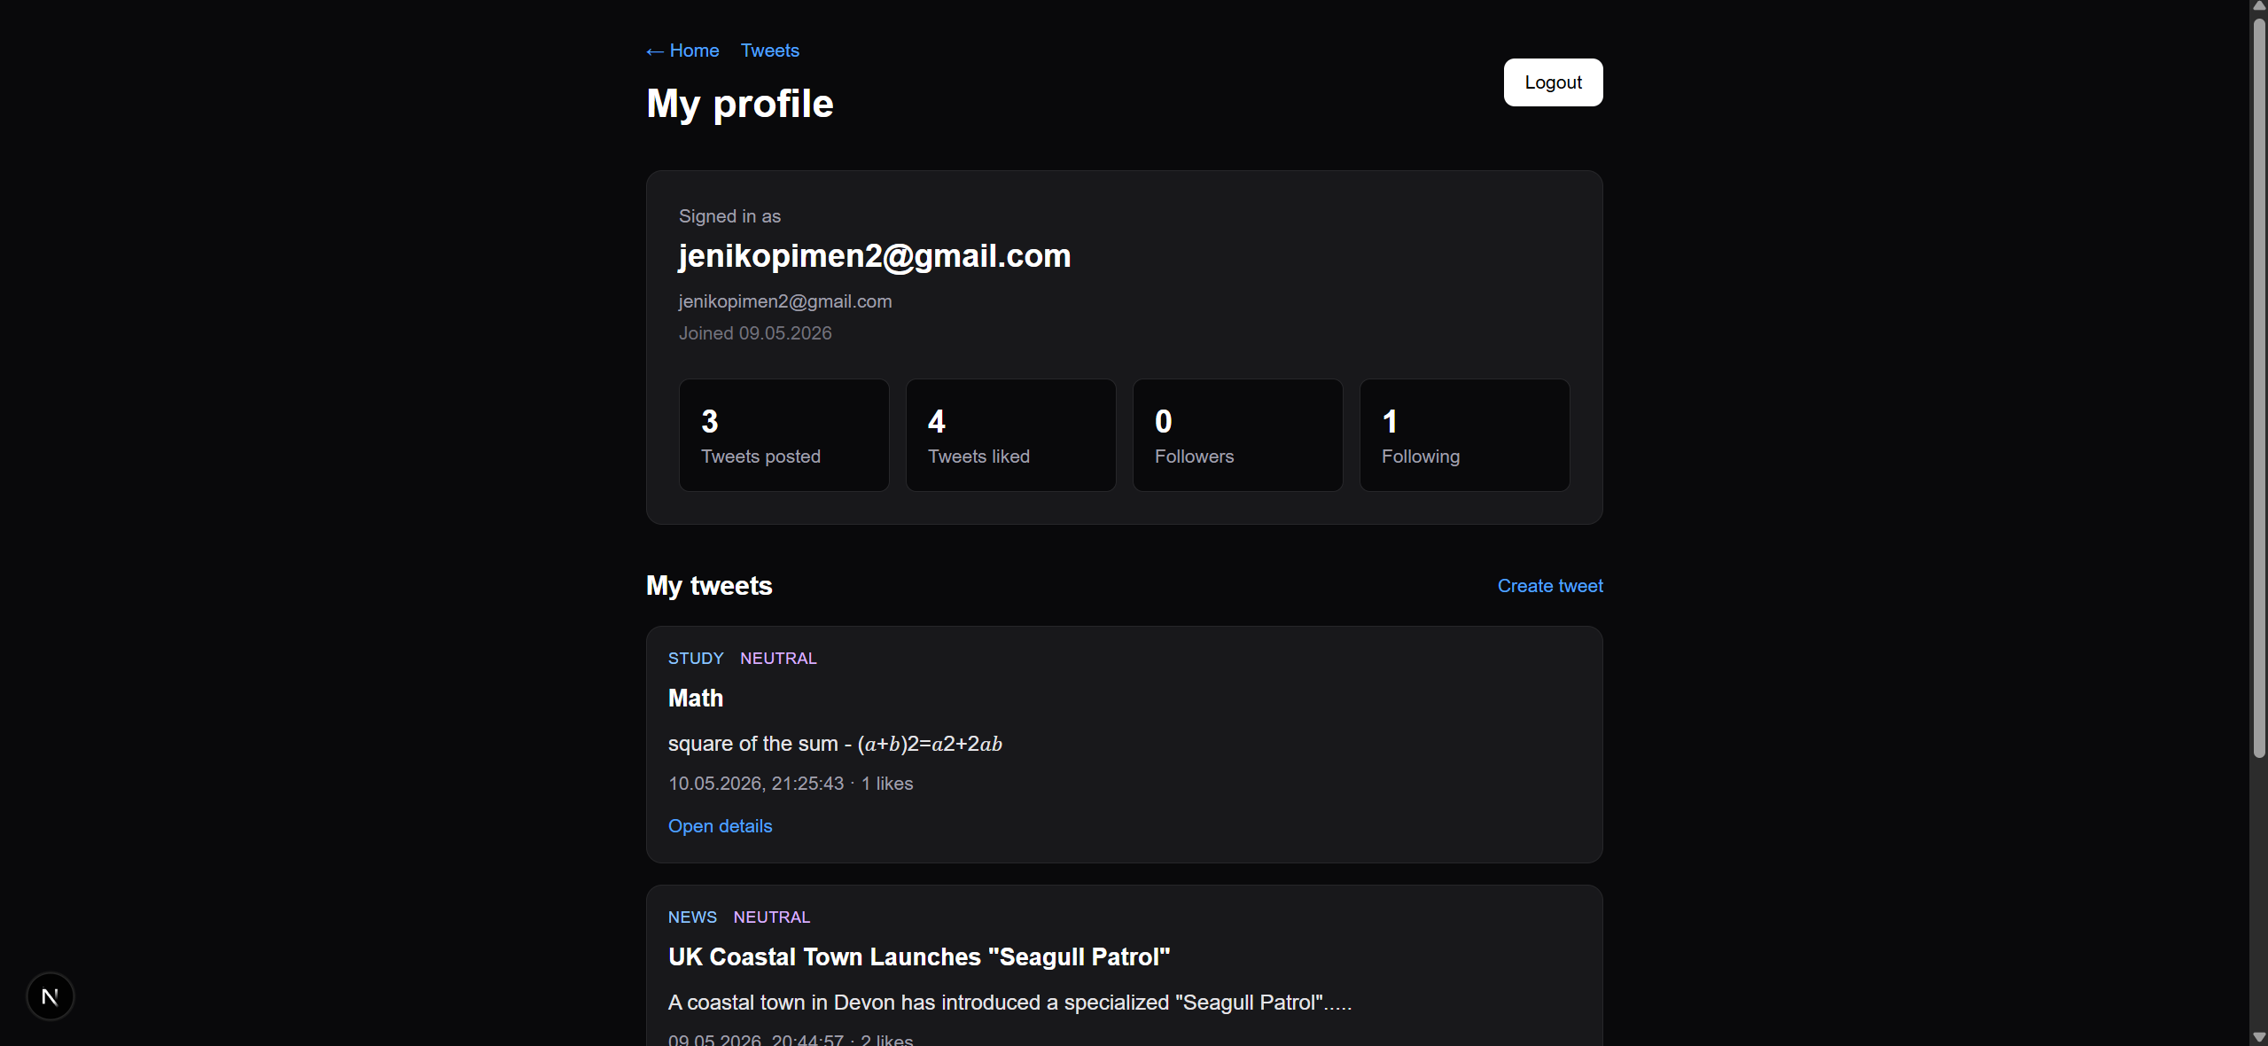

User Profile / Follow Page
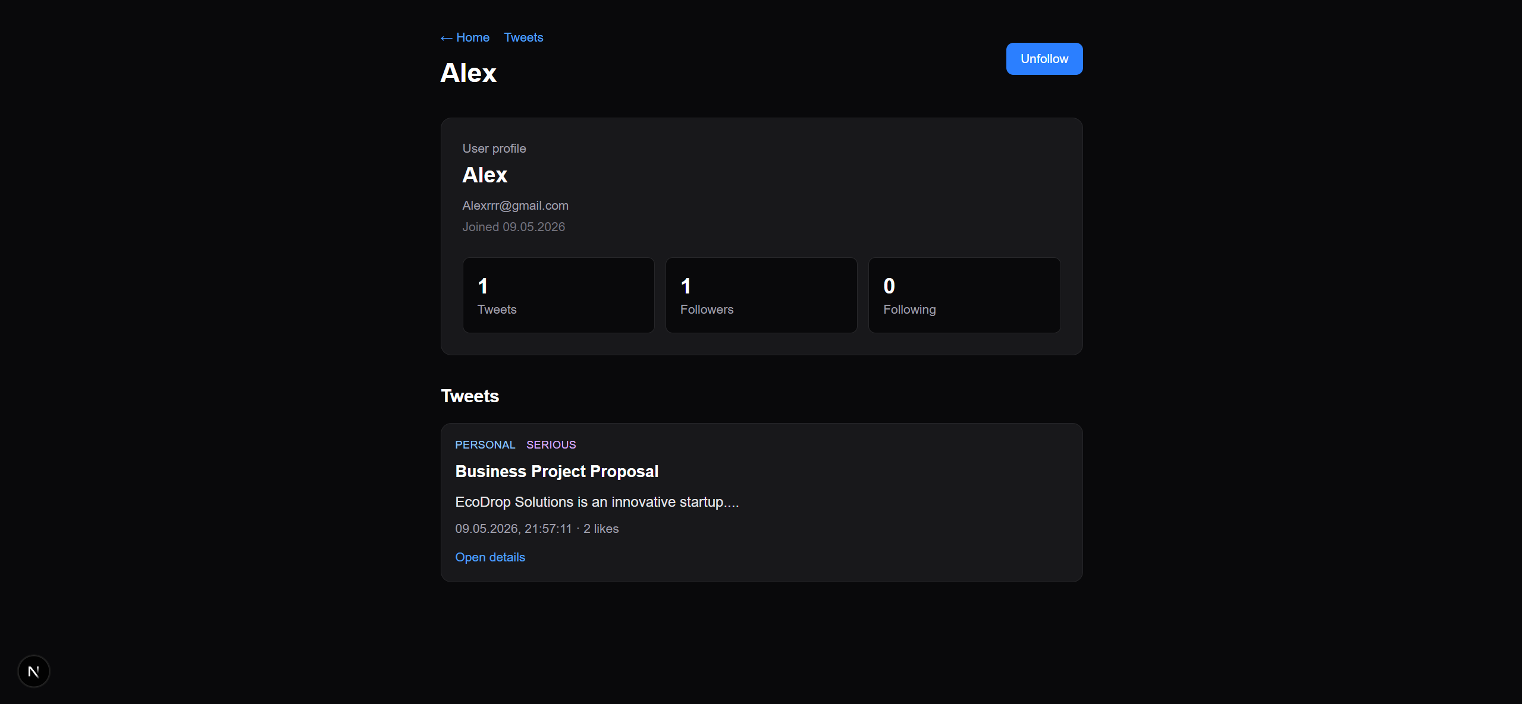

13. Conclusion
The project meets the main requirements for a Next.js full-stack application with authentication, Prisma database access, CRUD functionality, details pages, validation, likes, follow/unfollow functionality, and documentation.

